**13. Architectural Models**

**Architectures:**

* The architectural models of the system are **n-Tier Architecture** (Client-Server Architecture) and **Layered Architecture**.

**Justification:**

* Scalability, ease of management, flexibility, and security.
* Most of web applications (if not all) are n-tier architecture.
* Distribution of data is straightforward.
* Suitable for projects with frequent updates, giving the clients fast updates.
* Makes effective use of networked systems, which reduces the hardware cost.
* Easy to add new servers/clients or upgrade existing servers.
* Supports incremental development of layers.
* Giving developers the ease of maintenance because of the distributed layers and the client don’t need to worry about the size of the application since the presentation layer is the only layer that its components is requested.
* Layers can be changed as far as their interfaces to other layers don’t change,

hence, providing some sort of portability.

* If an interface of a layer is changed the only part of the system that need

modifications is the one connected by that interface.

**Tiers and Layers:**

* 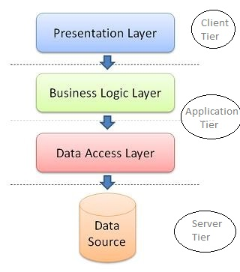In the following figure there are (N-layers) distributed at (N-tiers) as explained below:
* Client tier: is presentation layer.
* Application tier: business logic and data layer.
* Server tier: there is data source layer.